APPLECROSS SENIOR HIGH SCHOOL

YEAR 11 HUMAN BIOLOGICAL SCIENCES

GENETICS TEST KEY ( updated 11/9/2013)

NAME:_________________________________ SCORE:______/ 25

Hints: Write your answers on this question paper in biro. One mark will be deducted for answers in pencil. Provide a key to symbols for every question requiring working out. Label fully each step in your working out. Unlabelled working will not gain marks.

- The gene for ability to taste the chemical PTC is dominant to the gene for inability to taste PTC. It is an autosomal trait. A woman who can taste PTC (although her father cannot taste PTC) marries a man who can taste PTC (although his mother cannot taste PTC). What phenotypic ratios would be expected in their offspring?

Key: (Required) (1)
Let T=Allele for Tasting PTC
t= allele for non-tasting PTC

Working (Required)

P phenotype: Taster x Taster

P genotypes: Tt x Tt (1)

Gametes possible: T, t x T, t

F1 genotypes possible: TT, Tt, Tt, tt (Only genotypes) (1)

(A fully labelled punnet square may be substituted)

F1 phenotypes possible: Taster, Taster, Taster, Non-taster (1)
(Only phenotypes; not heterozygous/homozygous)

Answer: The phenotypic ratios expected in the offspring would be: 3 Taster:1 Non-taster (1)

Must be a ratio; the working out must indicate how the ratio was determined from the F1 genotypes. No marks at all for an answer with no working out or inadequate working out)

TOTAL [5 marks]
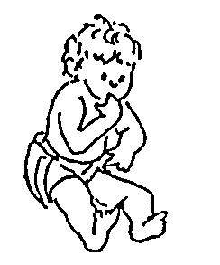
2. Huntington’s disease is a disorder of the nervous system in which the victim gradually loses control over his/her body. The symptoms don’t appear until mid-life. It causes premature death.
Huntington’s disease is caused by an autosomal dominant gene. A normal male marries a female who is heterozygous for Huntington’s disease. What is the probability that they will produce a child who will develop Huntington’s disease in later life?
Key: (Required)
Let H=Allele for Huntington’s disease

h = Allele for not Huntington’s disease

Working Required - No working ;no marks for answer

P phenotype: Huntington’s disease x Normal (1)
(sex is not required) (heterozygous refers to genotype)

P genotype: Hh x hh (1)

Gametes possible: H, h x h, h

F1 genotypes possible: Hh, Hh, hh hh (1)

F1 phenotypes possible: Disease, Disease, Normal, Normal (1)

Probability of a child with Huntington’s disease P (Huntington’s) = 0.5 (1)
TOTAL [5 marks]

Terminology (Spelling will be penalised in questions 3-7.)

3. A pair of alleles which are the same is termed ____HOMOZYGOUS_______(1)

4. A pair of chromosomes which contain genes controlling the same traits is called

____HOMOLOGOUS________(1)

5. An inheritance pattern in which a pair of different alleles both partially show their effect, is called
_____CODOMINANCE______(1)

6. The Human Genome Project determined the location of many human genes.
The location of a particular gene is called its
_____LOCUS______________(1)

7. The display of the chromosomes from one cell, showing the chromosomes arranged in pairs, is called a
_____KARYOTYPE_________(1)

TOTAL [5 marks]
8. Haemophilia is a recessive, X-linked trait. A haemophiliac male marries a female whose blood clots normally, and who has no family history of haemophilia. She is pregnant and an ultrasound shows that the foetus is male. What is the chance of this child being a haemophiliac?

Key to symbols:

Let X^{N}= Allele for normal blood clotting on X chromosome

X^{n}= Allele for haemophilia on X chromosome

Y= Y chromosome

Working:

P phenotype: Haemophiliac male x Normal female (1)
(Both the sex of the person and the trait must be named)

P genotype: X^{n}Y x X^{N}X^{N} (1)

Gametes possible: X^{n} , Y x X^{N} , X^{N}

F1 genotypes possible: X^{N}X^{n}, X^{N}X^{n}, X^{N}Y, X^{N}Y (1)

F1 phenotypes possible: normal female, normal female, normal male, normal male (1)
(Both the sex of the person and the trait must be named, incorrect if carrier or heterozygote are used which refer to genotype.)

Give no marks if working is autosomal. If symbols are not sex-linked but working is correct for sex linkage, give up to 4 marks.

The F1 genotypes must correspond to the matching phenotypes for full marks.

Chance of this child being haemophiliac: P(Haemophiliac male) = 0 (1)

[5 marks]
9. Pedigree of Duchenne Muscular Dystrophy.

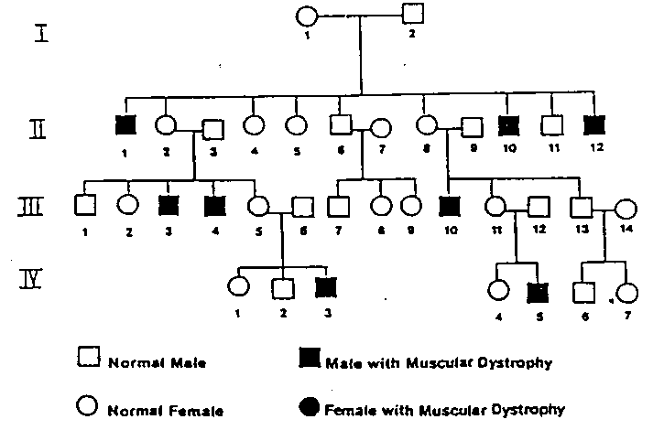

(i) Choose from the following list, all the words which describe the mode of inheritance of Duchenne Muscular Dystrophy : dominant; recessive; autosomal; X-linked.

Answer: X Linked(1) recessive (1). No marks at all if additional answers given. [2 marks]

- What are the genotypes of the following individuals shown in the above pedigree? Provide a key to your symbols.

Key: No key , no marks (1)

Let X^{N}= Allele for normal muscle development on X chromosome

X^{n}= Allele for Duchenne Muscular Dystrophy on X chromosome

Y= Y chromosome

Person II 1 = X^{n} Y (1)

Person III 5= X^{N}X^{n} (1)

[5 marks]

